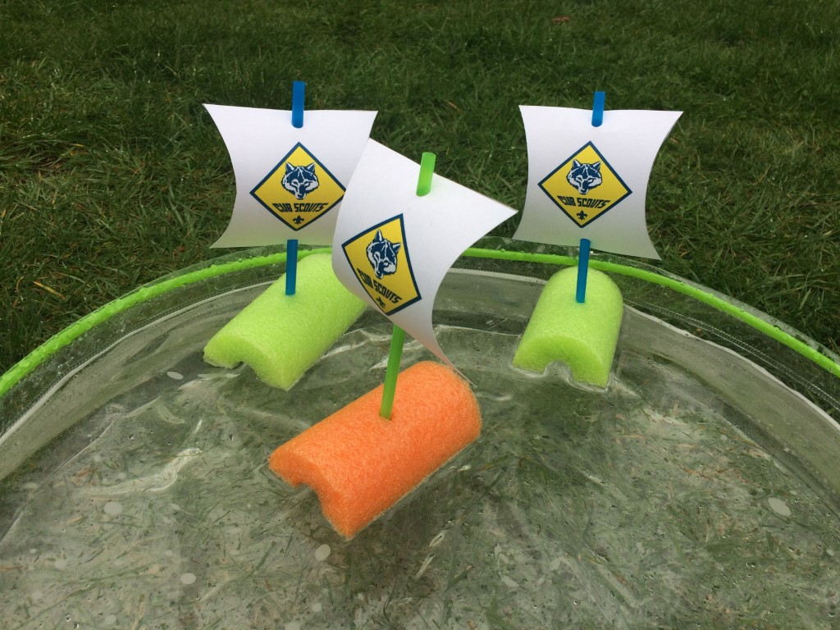

Pack 1776

Join us for our

Recruitment Regatta

Build a boat, bring a friend, and share the joy of Scouting

June 9th from 10am – 2pm

Lunch will be available for purchase

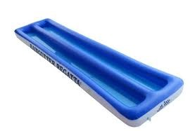

At Saints United Lutheran Church

Bring a friend, if they join, you will earn

the recruiter badge.

Questions or more information contact: [cubmaster@cubscoutpack1776.org](mailto:cubmaster@cubscoutpack1776.org)